Version 1.0
7/31/2017
Data Portal Access Application Instruction Manual

Table of Contents
1. Introduction 1
1.1 Overview 1
1.2 Conventions 1
2 Who Can Apply for Access to the Data Portal and When? 2
3. Prepare for the Application 3
3.1 Information about the Receiving Organization and Project Team 3
3.1.1 About IP Addresses 3
3.2 Information about the Research Project 4
3.3 Information about the Data Request 4
4. Get Started 6
4.1 Setup and User Access Considerations 6
4.1.1 Create a New Account 6
4.2 Login 9
4.3 Navigation 10
4.4 Status Bar 11
4.5 Exit the System 12
5 Create Your Data Portal Access Application 13
5.1 Enter Receiving Organization(s) 13
5.2 Add Proposed Research Project Information 14
5.3 Enter Data Request Details 16
5.4 Files 16
5.5 Upload Files Within Sections 17
5.6 Edit the Application 18
5.7 Review the Application 19
5.8 Email Receiving Organizations’ PPOs to Add Their Information 20
5.9 Submit the Application 21
6 Notification and Final Steps 23
7 Troubleshooting and Support 24
Appendix
A Acronyms A-1

List of Figures
Figure 1: Click Start your Data Portal Access Application. 6
Figure 2: Create new account from the User account page. 7
Figure 3: Answer the CAPTCHA test questions and click Verify. 8
Figure 4: Click Create new account. 8
Figure 5: Click the log in link. 9
Figure 6: Start, view, or edit your application on the Data Portal page. 10
Figure 7: Click the green plus sign to open a section; click the minus sign to close it. 11
Figure 8: Status Bar. 12
Figure 9: Click log out on the top of the page to exit the system. 12
Figure 10: The Create Data Portal Access Application page. 13
Figure 11: Clicking the Save button returns you to the Create Data Portal Access Application page, where you can view saved information and continue filling out the application. 14
Figure 13: From the Data Portal Access Application page, click Edit to return to the Create Data Portal Access Application page. 15
Figure 14: Enter Data Request Details and its subsections. 16
Figure 15: An uploaded file in the Files section. 17
Figure 16: An uploaded file. 18
Figure 17: Edit takes you to the Create the Data Portal Access Application page. 18
Figure 18: From the Data Portal Access Application page, click Edit to return to the Create Data Portal Access Application page. 19
Figure 19: Click View to review all information saved in the application. 20
Figure 20: Email all PPOs from the Data Portal Access Application page. 21
Figure 21: Submit the application. 21
Figure 22: Address all errors that are displayed in the Status Bar. 22
Figure 23: A successfully submitted preliminary application. 22
Figure 24: Links to assistance from SAMHDA’s Help Desk are in the footer on every page. 24

1. Introduction

1.1 Overview
The Data Portal at the Substance Abuse and Mental Health Data Archive (SAMHDA) website will offer confidential datasets from the Center for Behavioral Health Statistics and Quality (CBHSQ) of the Substance Abuse and Mental Health Services Administration (SAMHSA).
The Data Portal grants access to the full restricted-use file for each year for the available datasets, including annual National Surveys on Drug Use and Health (NSDUHs) and adult clinical interview data, annual Drug Abuse Warning Network (DAWN) surveys and medical examiner data, among others. Approval for access is required to protect identifiable data from disclosure.
This instruction manual will assist you with your online application for secure remote access to the Data Portal. The online application is easy to navigate and provides step-by-step instructions. This instruction manual will
- assist you in determining whether you are a qualified candidate before you apply,
- help you prepare by listing the information you will need,
- orient you to the application system,
- explain what to expect after you submit your application, and
- explain the final steps to approval.
For more information, please refer to Information Needed to Complete the Data Portal Access Application, which includes examples of answers to the application fields. To prepare for your application, you can access an editable Microsoft Word version of the document and replace the examples with your application information.

1.2 Conventions
This instruction manual includes screen captures and corresponding narrative guidance to describe how to use the SAMHDA Data Portal Access Application System. The term “portal” is also used to refer to the Data Portal.
Every effort has been made to keep the screen captures and formatting conventions in this document up to date. In some instances, there may be minor differences between on-screen text and figures. These differences should not affect the user’s ability to navigate the application system.
The following conventions are used in this instruction manual:
- Page names and tabs: Bold black text; for example, the Data Portal page or tab.
- Hyperlinks: Blue underlined text.
- Buttons: Bold italic text; for example, the Submit button.
- Lists: Numbered lists identify the steps required to complete a task.

2 Who Can Apply for Access to the Data Portal and When?
CBHSQ provides confidential data only to qualified Receiving Organizations in the United States. Individual researchers must apply through a recognized Receiving Organization (e.g., a government agency, university, research organization). Applications for access may be submitted only during the Call for Applications period. Calls for Applications are announced via the SAMHDA e-newsletter and on the Data Portal. Applications will be accepted only during the Call for Applications period.
The Principal Project Officer (PPO) will serve as the primary project contact person at the Receiving Organization. The PPO must be directly employed at the Receiving Organization (i.e., he or she cannot be a contractor, temporary employee, visiting professor, or outside consultant to the Receiving Organization). Research staff must be directly employed by or students currently enrolled at the Receiving Organization. At institutions of higher education, the PPO must have an advanced degree (e.g., PhD, JD, MD, EdD). Usually, PPOs serve as principal investigators of research projects or sponsor PhD students conducting dissertation research. Graduate students may not apply for access and must find a qualified faculty member to apply on their behalf.
The Receiving Organization headquarters, related business offices, and/or research site locations must be in the 50 states or District of Columbia. An application will not be approved if the Receiving Organization’s place of business is within a private residence.
If there are multiple Receiving Organizations, then a PPO at one of the Receiving Organizations must be designated on the Application for Access as the Primary Contact for the overall project.

3. Prepare for the Application
This section describes information needed to apply. After preliminary approval, additional documentation must be uploaded to the application for final approval (see Section 6: Notification and Final Steps).

3.1 Information about the Receiving Organization and Project Team
The following information is needed about the Receiving Organization(s) and the project team:
- Organization name.
- Address.
- URL.
- The PPO: Who will be the contact person for the project at the Receiving Organization?
- The Receiving Organization Representative (ROP): Who has the legal authority to bind the organization to a contract?
- Team members: An organization may have up to 10 team members, including the PPO and excluding the ROP.
- Roles: For each team member, you will need name, title, department, phone number, fax number, email address, and description of each member’s role.
- Is more than one Receiving Organization involved in the project? If so, you will need the organization’s name and one team member (name and email address) who will serve as the PPO for each Receiving Organization.
- Certifications: National Institutes of Health Multiple Project Assurance (MPA) Certification Number or Federalwide Assurance (FWA) Certification Number and expiration date (if available). If MPA or FWA Certification Number is not available, you will need the following:
- A detailed description of the organization.
- The organization’s funding sources.
- Any research policies regarding scientific integrity or misconduct about human subject research that covers a secondary analysis of data.
- A description of the organization’s experience with confidential data.
- A copy of the organization’s Institutional Review Board (IRB) approval, if required.
- Security: The street address and description of the secure project office location(s) and a description of the security measures. Note users cannot access data from off-site locations, such as a home office.
- Photographs of the secure project office location(s).
- All computers with project access at the Receiving Organization’s location (brand, make, model, serial number, operating system, and IP address).

3.1.1 About IP Addresses
Every computer connecting to the Internet has a unique IP (Internet Protocol) address assigned to it.
Your computer may connect through a fixed IP address, or your organization may assign an IP address from a fixed range of IP addresses. The IP addresses listed in the Receiving Organization(s) section of the Data Portal application must be public-facing IP addresses. Commonly used forms of IP addresses that are not public facing, but internal organizational addresses, begin with “192.168.”, “172.”, or “10.”
Please contact your IT group to verify what your public-facing IP address or range of addresses is for the computer(s) you will use. Ask the following questions:
- Are you using network address translation (NAT)? If so, what is the public-facing IP?
- If not, are you using a static IP? If so, what is the static IP?
- If not, are you using Dynamic Host Configuration Protocol (DHCP)? If so, what is the full range (subnet) for this computer? Note: Fixed IP addresses are preferred.
- Can the project’s computers each be assigned a fixed IP address?

3.2 Information about the Research Project
The following information will be needed about the research project:
- Project title.
- Project description, including:
- Research or policy questions being addressed.
- The research plan.
- The potential significance and application of results.
- The relevance of the research to the U.S. Department of Health and Human Services and SAMHSA mission to reduce the impact of substance abuse and mental illness on America’s communities.
- Feasibility of the research, given the data and resources available.
- Approximate sample sizes you will need for your analyses.
- Disclosure considerations and how the project will address them.
- Related experience of the PPO and project team members.
- Relationship of past work and publications by the project team to the proposed research.
- Use of results.
- Project start date and end date.
- Dependencies.

3.3 Information about the Data Request
The following information will be needed about the data request:
- Software you plan to use. While working with the confidential data, you can only use software provided within the Data Portal, which includes the following:
- SAS 9.3, which includes the Education Analytical Suite, SAS Enterprise Miner client, SAS/GIS, and SAS/SPECTRAVIEW
- SPSS 19 with add-ons for regression models and advanced models
- Stata/SE 13
- SAS-callable SUDAAN 11
- R 3.4.1
- Microsoft Office 2010 (Access, Excel, InfoPath, OneNote, PowerPoint, Publisher, and Word)
- Preferred data format. Options include the following:
- N/A
- SAS 9.3, which includes the Education Analytical Suite, SAS Enterprise Miner client, SAS/GIS, and SAS/SPECTRAVIEW
- SPSS 19 with add-ons for regression models and advanced models
- Stata/SE 13
- SAS-callable SUDAAN 11
- R 3.4.1

- Microsoft Office 2010 (Access, Excel, InfoPath, OneNote, PowerPoint, Publisher, and Word)
- Other software needs.
- Specific CBHSQ datasets needed.
- Any specific NSDUH restricted data or variables (data and variables not in the public-use files) needed.
- State the reasons why the NSDUH and/or DAWN data in the Public-use Data Analysis System (PDAS) and the Restricted-use Data Analysis System (RDAS) are not adequate for conducting your research.
- State why your research project can only be conducted using the confidential data. A list of restricted-use variables is posted on the SAMHDA website.
- Other data.
- What datasets from non-CBHSQ sources do you plan to merge with the confidential data within the Data Portal? Are those data public or not?
- If the data you wish to merge within the Data Portal are restricted, you will be asked to provide verification that you have permission to use those data and that the Confidential Data Use and Nondisclosure Agreement for those data allows for merging with other data.
- Why are these external data necessary for the proposed research project?

4. Get Started

4.1 Setup and User Access Considerations
Accessing the system requires a computer, smartphone, or tablet connected to the Internet using Google Chrome (any version), Firefox or Internet Explorer (version 11.0 or higher). The system may not display or function correctly with other browsers.

4.1.1 Create a New Account
Unless an account has been created for you, before using the system you must create a new account. To create a new account, follow these steps:
- Navigate to https://www.datafiles.samhsa.gov/.
- Click the Data Portal tab.
- Click Start your Data Portal Access Application (see Figure 1).
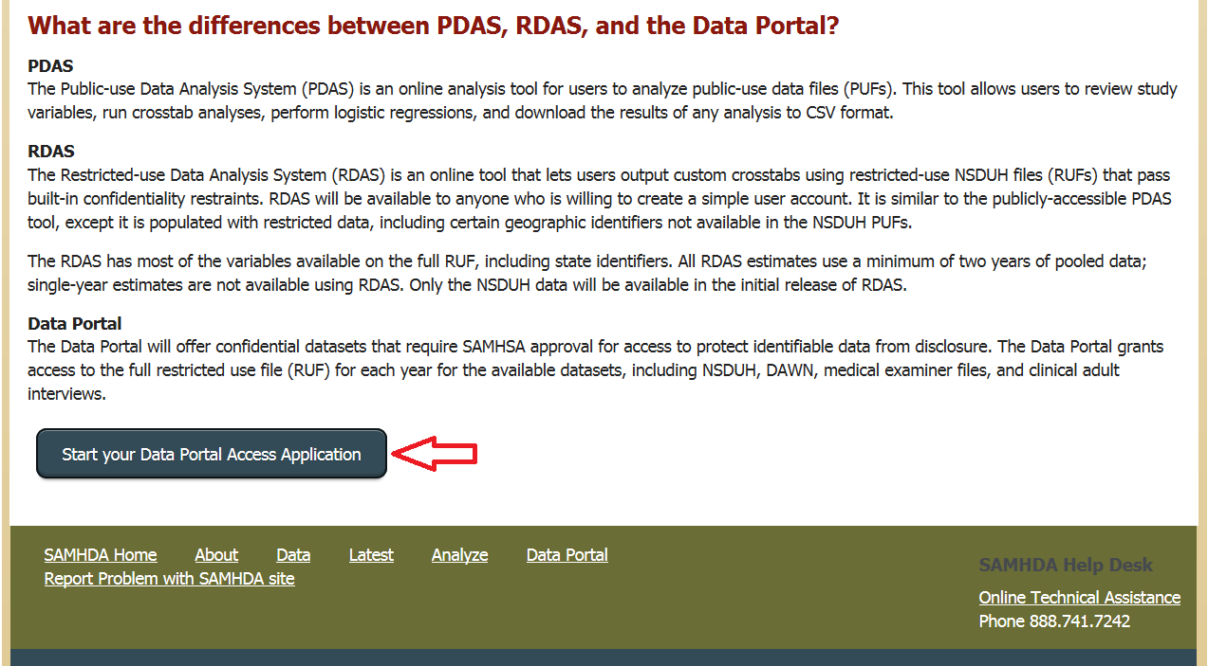
Figure 1: Click Start your Data Portal Access Application.
- On the User account page, click Create new account in the upper-left corner of the screen, as seen in Figure 2.
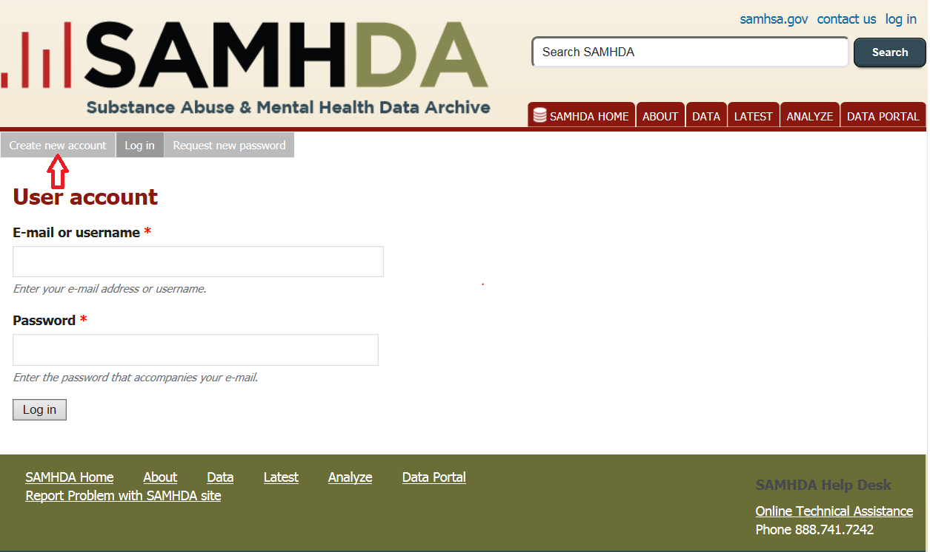
Figure 2: Create new account from the User account page.
- Fill in your email address, check the “I’m not a robot” checkbox, and answer the test questions, as shown in Figure 3.
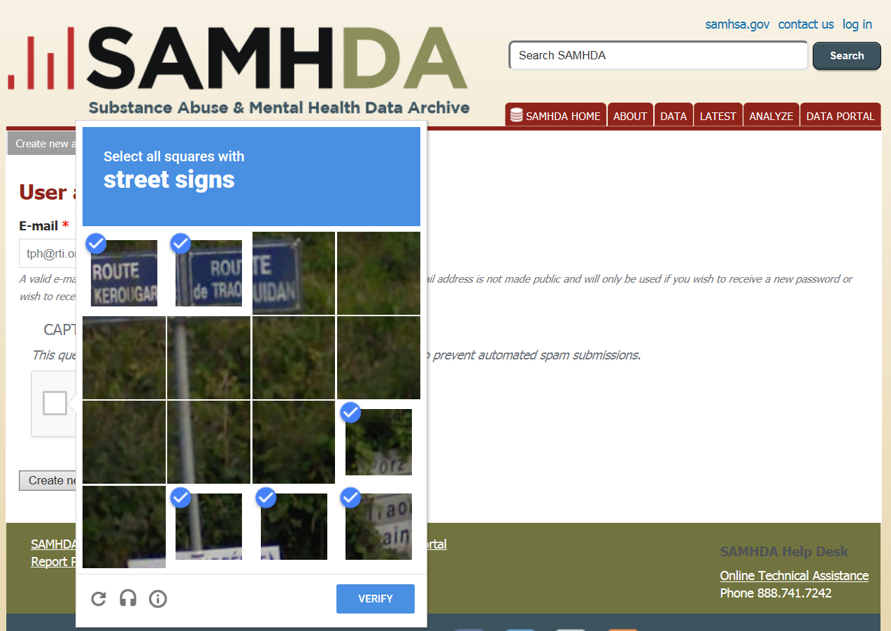
Figure 3: Answer the CAPTCHA test questions and click Verify.
- Click Create new account (see Figure 4).
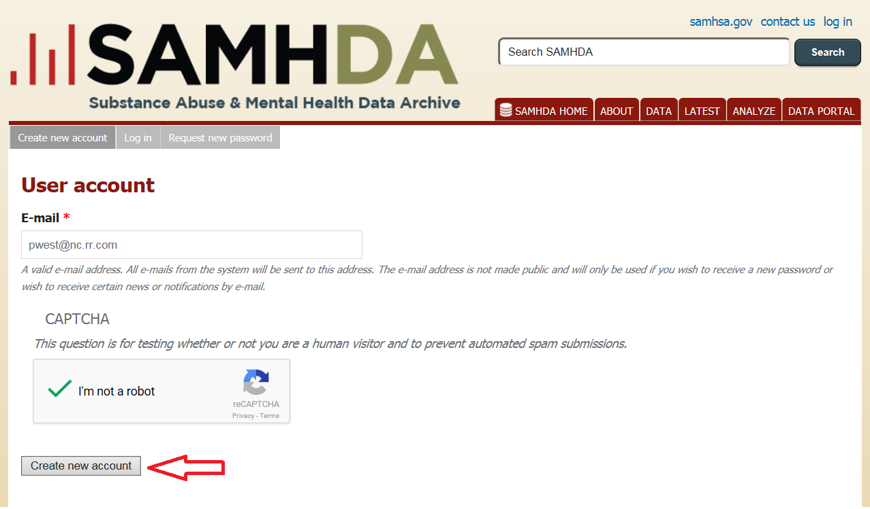
Figure 4: Click Create new account.
- Fill in your user account information.
- After submitting your information, check your email for login information from SAMHSA. The email will contain a link for first-time login. This link can be used only once to log in and will lead you to a page where you can reset your password.

4.1.1.1 About Passwords
When changing your password, keep the following in mind:
- You must use a mixture of letters, numbers, punctuation, and special characters. Use at least two alphanumeric characters, plus advanced special characters, which include A–Z, 0–9, and !@#$%^&*()-_+={}`~’”?<>:;|\,./[]
- You must use a minimum of 8 and a maximum of 16 characters.
- You must use upper and lower case.
- Do not choose a name associated with you in any way (middle initial, family names, pet’s name, your favorite team’s name, films, etc.)
- Do not use portions of a user ID.
- Do not use simple keyboard patterns.
- Do change your password frequently.
- Never give your password to anyone.
- Do not write your password down.
- Do not share a common password between computers or applications.
- Do not send your password via email.
You can report any difficulty with your password to the SAMHDA Help Desk, or call 888.741.7242.

4.2 Login
After an account has been created, you may log into the system. Follow these steps to log in:
- Navigate to the SAMHDA website at https://www.datafiles.samhsa.gov/.
- Click log in at the top of the screen, as shown in Figure 5.
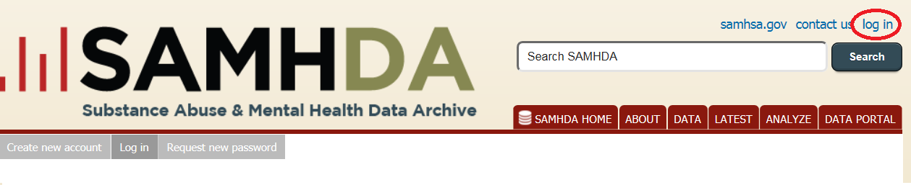
Figure 5: Click the log in link.
- Enter your email or username and your password, and then click log in. Remember that passwords are case sensitive. If you forgot your password, click Request New Password at the top of the page.
- From your User Account page, click the Data Portal tab.
- Click the Start your Data Portal Access Application button to start a new application, or select the application from My Data Portal Access Applications to view or edit the information (see Figure 6).

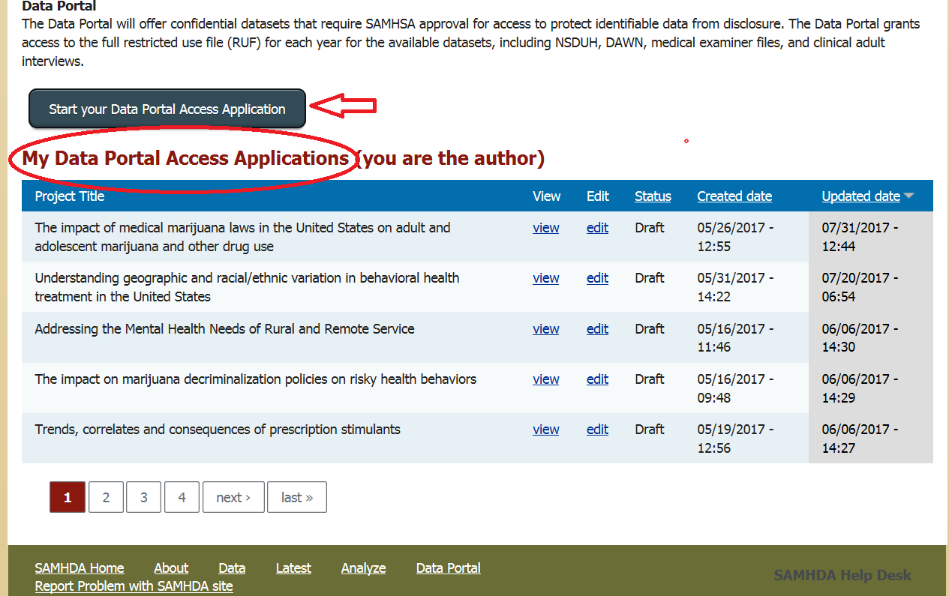
Figure 6: Start, view, or edit your application on the Data Portal page.
- From the Data Portal page, you can start a new application or view and edit an application in progress.

4.3 Navigation
On-page navigation is standard; however, note the following:
- Sections in the application are in green font with a plus sign () on the bar. Clicking a plus sign opens a section. When the section is open, a drop-down box appears, and the plus sign becomes a minus sign (). Clicking the minus sign collapses the section (see Figure 7).
- Subsections in the application are in blue font and have down arrows (˅) and up arrows (˄). Clicking a down arrow (˅) opens a drop-down form. When the drop-down form appears, the down arrow becomes an up arrow (˄). Clicking the up arrow closes the form.
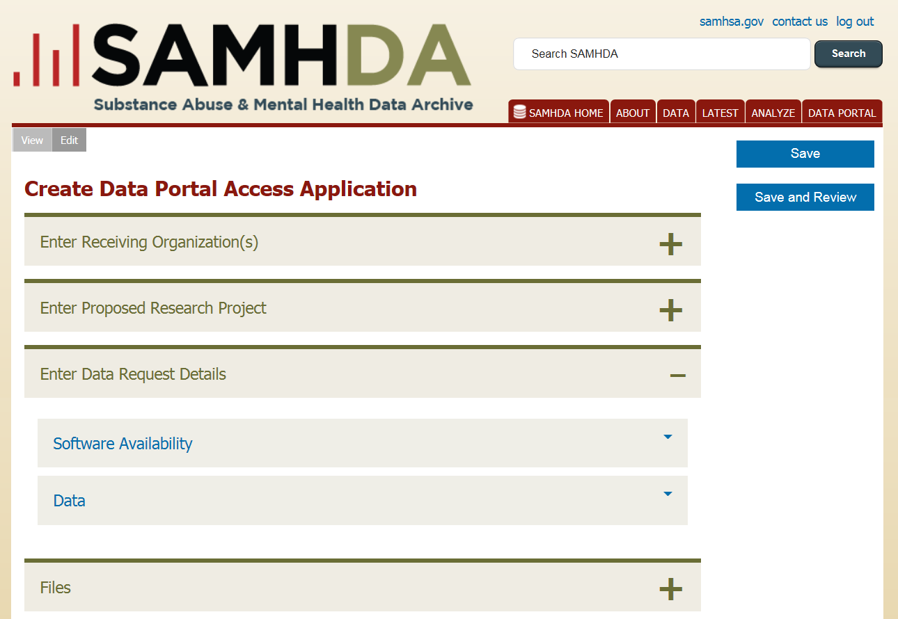
Figure 7: Click the green plus sign to open a section; click the minus sign to close it.
- The Save button saves the information entered, collapses the drop-down forms, and returns you to the Create Data Portal Access Application page.
- The Save and Review button saves the information entered and takes you to the Data Portal Access Application page, where all information entered in the application is displayed for review.
- When you are logged into the SAMHDA website, clicking the Data Portal tab from any page takes you to the main Data Portal page, where you can start a new application or view and edit an application in progress until it is submitted.

4.4 Status Bar
The status of your application is displayed in the Status Bar in shaded areas at the top of the screen. The Status Bar (Figure 8) will indicate the status of your application, such as when it has been created, updated, and submitted; whether there are errors to be addressed; when PPOs have been sent an email; when the application is accepted for preliminary approval; and when final approval is granted.
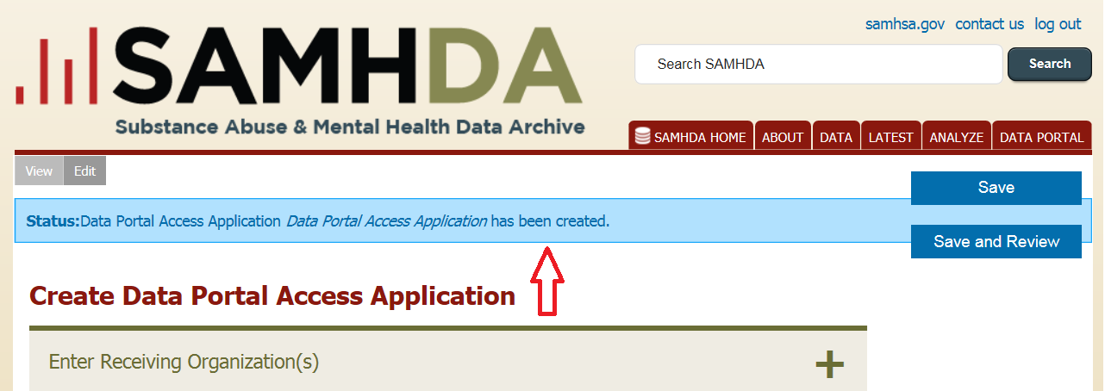
Figure 8: Status Bar.

4.5 Exit the System
Exit the system by clicking log out on the upper-right corner of the screen or by closing your browser (Figure 9). Be sure to save your information before logging out.
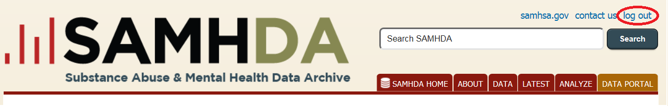
Figure 9: Click log out on the top of the page to exit the system.
If you accidentally close your browser, Autosave will activate. When you reopen the form, a message will pop up offering you the option to restore your data. Note that Autosave does not work when you log out or switch computers.

5 Create Your Data Portal Access Application
After logging in to SAMHDA’s site, click the Data Portal tab, then click Start your Data Portal Access Application. The Create Data Portal Access Application page will display the application’s four main sections (shown in Figure 10):
- Enter Receiving Organization(s)
- Enter Proposed Research Project
- Enter Data Request Details
- Files
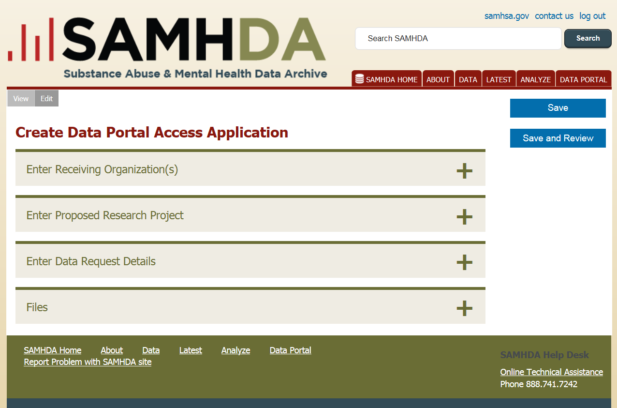
Figure 10: The Create Data Portal Access Application page.
You must fill out the first three sections to complete your application, but you do not have to fill out the sections in any specific order. Uploading files to the Files section is optional for your application. Until the application is submitted, PPOs can view and edit all sections of the application (see Section 5.6: Edit the Application, and Section 5.7: Review the Application for more information).
Click the Save or Save and Review button when finished entering information.

5.1 Enter Receiving Organization(s)
To enter Receiving Organization information, follow these steps:
- From the Create Data Portal Access Application page, click Enter Receiving Organization(s) or the plus sign next to it to open the form.
- A Receiving Organization bar displays. Click the blue down arrow to open the form. Click the down arrows next to each subsection (Address, Project Team, Certification, and Security) and fill in all required fields.
- Upload documents as directed.
- Each Receiving Organization must have one team member designated as the PPO with the PPO’s email address.
- After you have completed information for the first Receiving Organization, you may click Add another Receiving Organization and fill in the same information. Continue to click Add another Receiving Organization until all Receiving Organizations are added. You do not have to fill in all information about each Receiving Organization, but you should fill in the name, role, and email address for a PPO for each Receiving Organization. Later, PPOs for each organization will be given access to complete the information for their Receiving Organization.
- Click Save to collapse the form and return to the Create Data Portal Access Application page. Reopen the section by clicking the plus sign and reopen the forms by clicking the down arrows, if needed.
- The Status Bar will display “Data Portal Access Application has been created.”
- Click the plus sign next to Enter Receiving Organization(s) to verify that all Receiving Organizations are listed (see Figure 11).
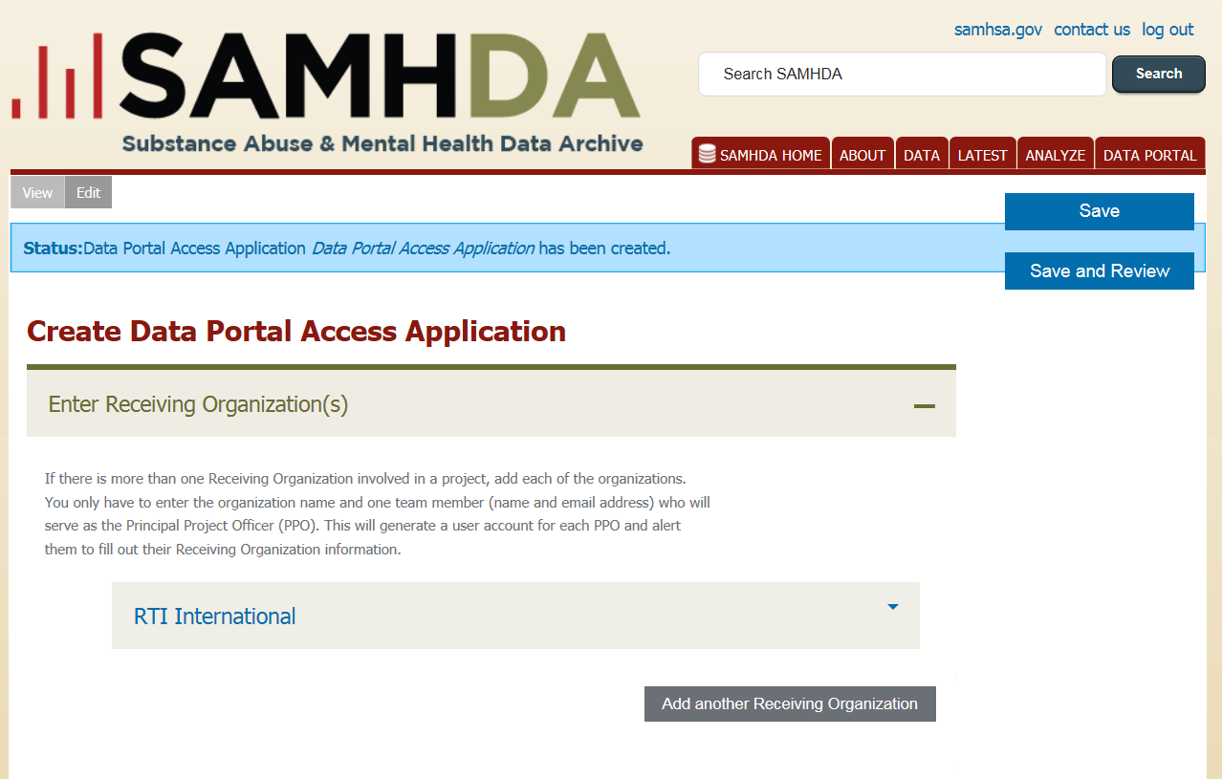
Figure 11: Clicking the Save button returns you to the Create Data Portal Access Application
page, where you can view saved information and continue filling out the application.
- While in a Receiving Organization’s file, you can also click Remove Receiving Organization to remove it.

5.2 Add Proposed Research Project Information
To add information about your proposed research project, follow these steps:
- From the Create Data Portal Access Application page, click Enter Proposed Research Project or the plus sign next to it to open the form.
- A Proposed Research Project bar displays. Click the blue down arrow to open the form. Click the down arrows next to each subsection (Project Description and Time Period) and fill in all required fields (see Figure 12).

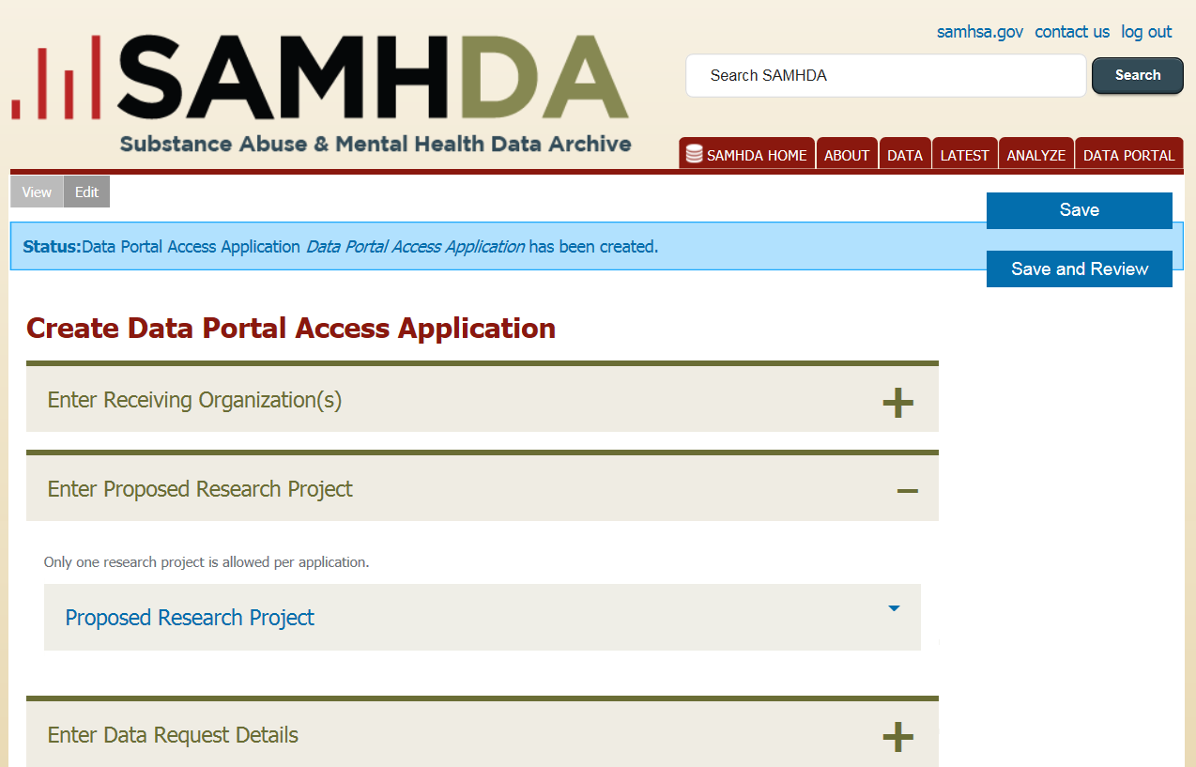
Figure 12: Enter Proposed Research Project information from the Create Data Portal Access Application page.
- Click Save to collapse the form and return to the Create Data Portal Access Application page. Reopen the section by clicking the plus sign, if needed.
- Click Save and Review to save the information and go to the Data Portal Access Application page. Return to the application, if needed, by clicking Edit at the top of the screen, as shown in Figure 13.
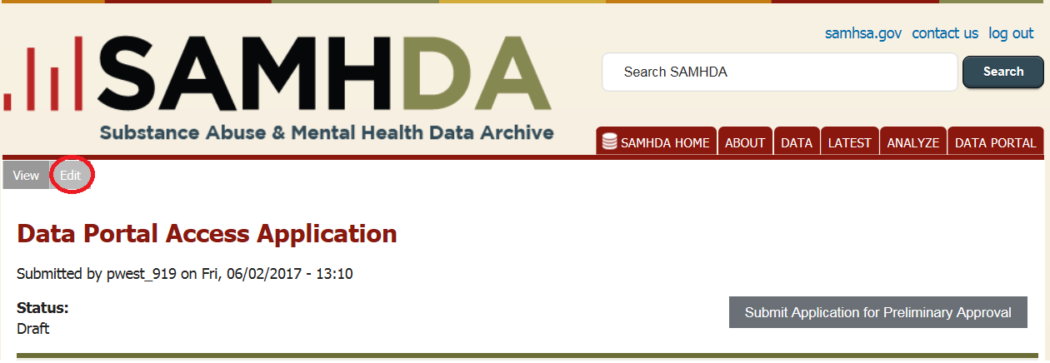
Figure 13: From the Data Portal Access Application page, click Edit to return to the Create Data Portal Access Application page.

5.3 Enter Data Request Details
To add details about your data request, follow these steps:
- From the Create Data Portal Access Application page, click Enter Data Request Details or the plus sign next to it to open the form.
- Click the blue down arrows next to each subsection (Software Availability and Data) and fill in all required fields (see Figure 14).
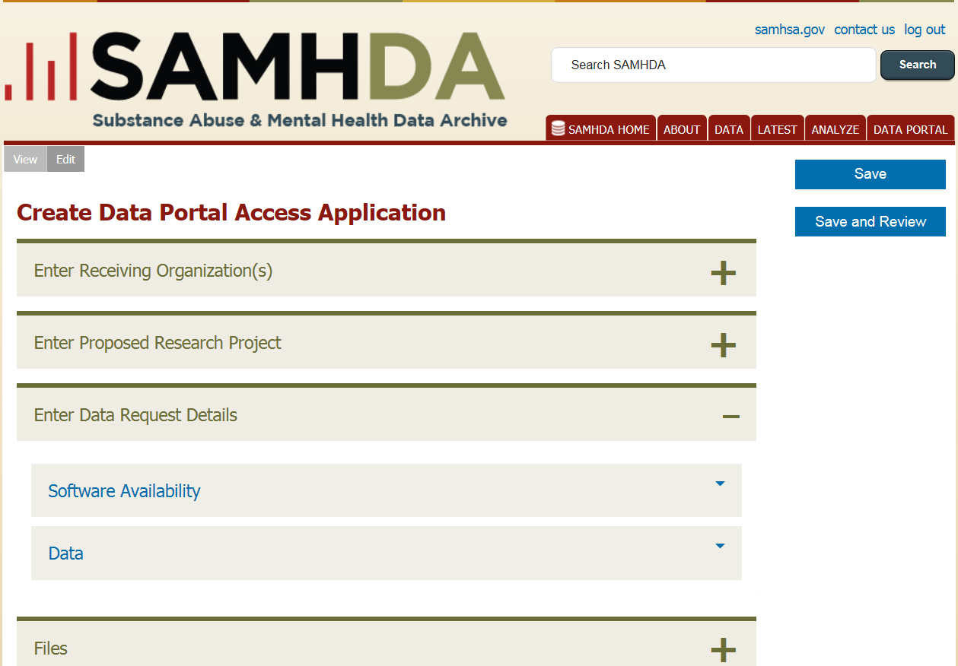
Figure 14: Enter Data Request Details and its subsections.
- Click Save to collapse the form and return to the Create Data Portal Access Application page. Reopen the section by clicking the plus sign, if needed.
- Click Save and Review to save the information and review information entered on the Data Portal Access Application page. Return to the application, if needed, by clicking Edit at the top of the screen.

5.4 Files
The Files section provides the ability to upload any documents needed to support your application. Adding files to this section is optional. For example, documents with special formatting (such as tables and formulas) that do not display correctly in the Enter Proposed Research Project section can be uploaded in the Files section. Files to upload must be less than 2 MB. The following common file formats are accepted: .jpg, .jpeg, .gif, .png, .doc, .docx, .txt, and .pdf.
To upload a file in the Files section, from the Create Data Portal Access Application page, follow these steps:
- Click Files or the plus sign next to it to open the section.
- Click the Browse button and navigate to the file location.
- Double-click the file or click Open to select the file.
- When the file appears in the window next to Browse, click Upload.
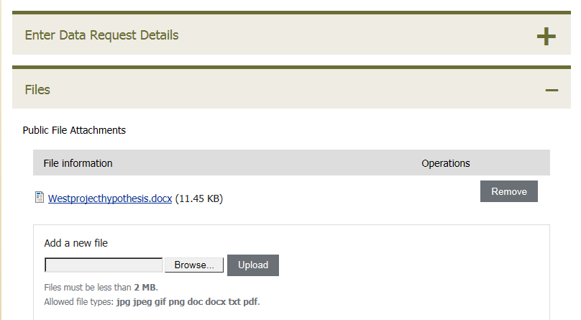
- The uploaded file will appear under Public File Attachments. If an incorrect file is uploaded, click Remove and repeat the above steps (see Figure 15).
Figure 15: An uploaded file in the Files section.

5.5 Upload Files Within Sections
The application provides instructions within each section about files needed before or after preliminary approval. Files to upload must be less than 2 MB. The following common file formats are accepted: .jpg, .jpeg, .gif, .png, .doc, .docx, .txt, and .pdf.
To upload a file, follow these steps:
- Click the Choose File button.
- Navigate to the file in your system and double-click the file or click Open.
- Confirm that the correct file name appears next to the Choose File button. If the file is not correct, click Choose File and try again.
- Click Upload.
- The uploaded file will appear on the application (see Figure 16).
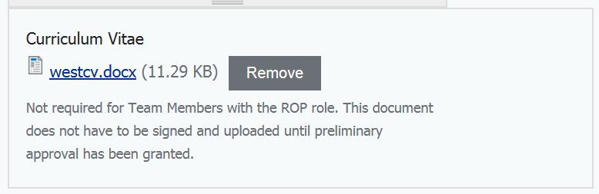
Figure 16: An uploaded file.

5.6 Edit the Application
Once an application is saved, it can be revised as needed from the Create Data Portal Access Application page. This page serves as the central location from where you can review and update an application in progress. From this page, you can open any section, add or revise information, and Save or Save and Review.
You can access the page in three ways:
- After you have saved your application, the system will display the My Data Portal Access Applications page after you log in. Click the edit link next to your application, as shown in Figure 17.
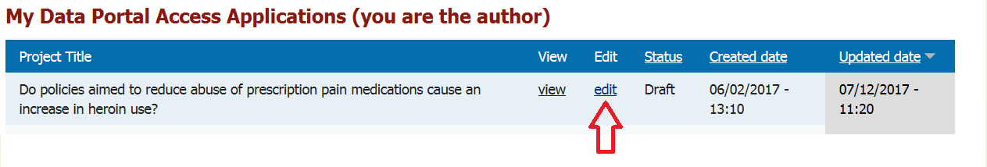
Figure 17: Edit takes you to the Create the Data Portal Access Application page.
- Click Save from any section of the application.
- Click the Edit link at the top of the Data Portal Access Application page as shown in Figure 18.
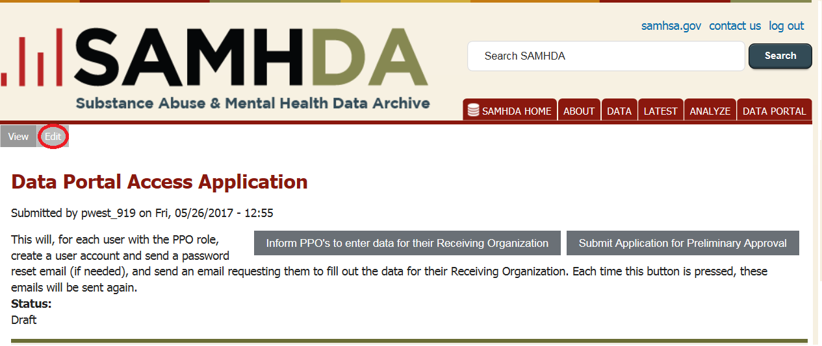
Figure 18: From the Data Portal Access Application page, click Edit to return to the Create
Data Portal Access Application page.

5.7 Review the Application
The Data Portal Access Application page displays all information entered in the application. If any information needs to be added or revised, click the Edit link at the top of the page to go to the Create Data Portal Access Application page.
You can access the Data Portal Access Application page in three ways:
- After logging in, the system will display the My Data Portal Access Applications page. Click the view link next to your application.
- Click Save and Review from any section of the application.
- Click the View link at the top of the Create Data Portal Access Application page, as shown in Figure 19.
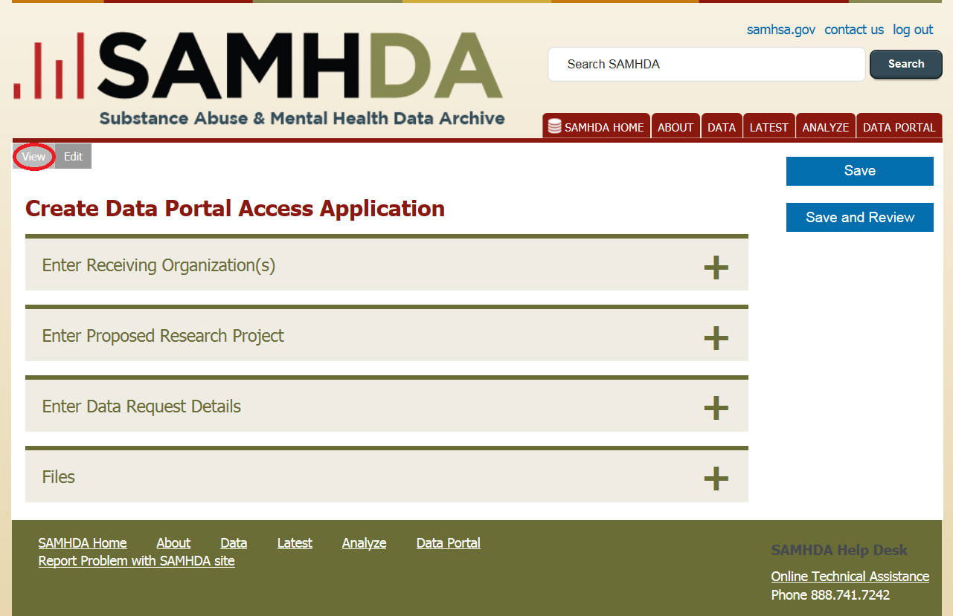
Figure 19: Click View to review all information saved in the application.

5.8 Email Receiving Organizations’ PPOs to Add Their Information
If an application has more than one Receiving Organization, the Primary Contact for the application can email the PPOs of all Receiving Organizations through the system. This is usually necessary to get the detailed information on the team, each team member’s computer, IP address, and other security details from the site.
Make sure that each PPO is identified in the Receiving Organization Team Members form, that you have identified them as a PPO in the Role field, and their email addresses are correct.
To contact PPOs using the system, follow these steps:
- Click the View link from the My Data Portal Access Applications section of the Data Portal main page or at the top of the screen on the Create Data Portal Access Application page.
- On the Data Portal Access Application page, click Inform PPOs to enter data for their Receiving Organization (see Figure 20).
- If successful, the Status Bar will display a message confirming the emails to the PPOs have been sent.
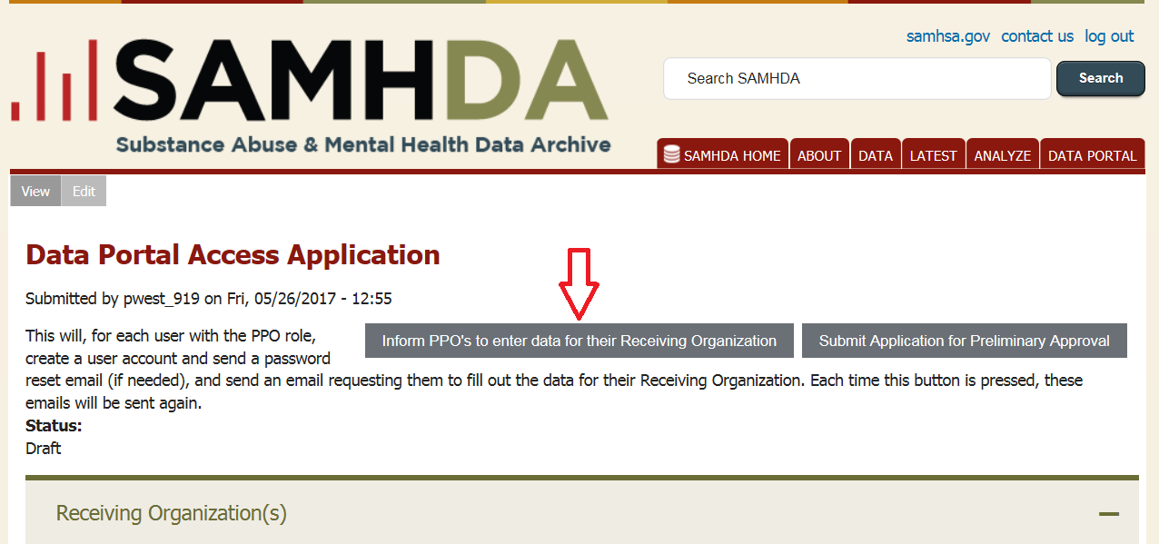
Figure 20: Email all PPOs from the Data Portal Access Application page.

5.9 Submit the Application
To submit the application, follow these steps:
- While in the application, click Save and Review to view all information in your application. Carefully review the application information on the Data Portal Access Application page. When you are ready, click Submit Application for Preliminary Approval, as shown in Figure 21.
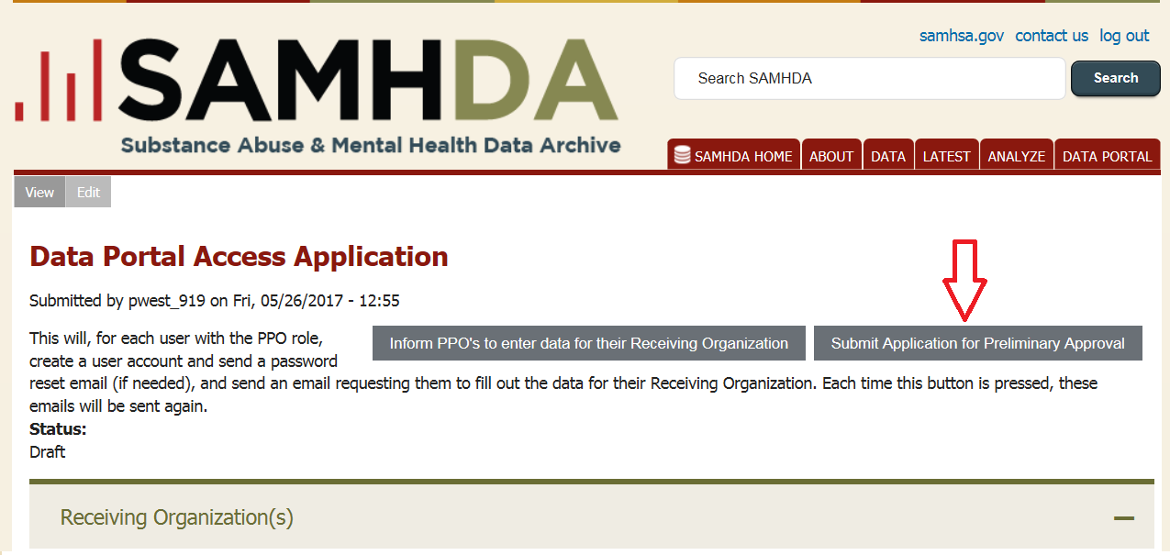
Figure 21: Submit the application.
- The system will validate your application. If there are any errors, the Status Bar will display a Warning message and information about the errors, as shown in Figure 22.
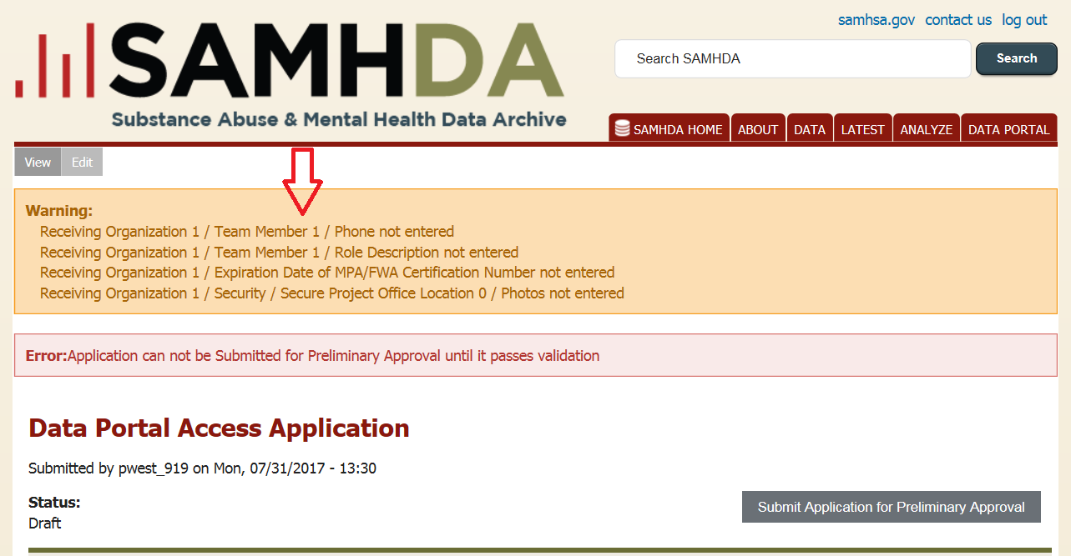
Figure 22: Address all errors that are displayed in the Status Bar.
- The application cannot be submitted until it passes validation. Click Edit at the top of the screen to address any errors.
- When finished, click Save and Review to return to the Data Portal Access Application page. Review and click Submit Application for Preliminary Review.
- When the application passes validation, the Status Bar displays “Application Submitted for Preliminary Approval” (see Figure 23). The submitted application is locked to prevent editing until preliminary approval.
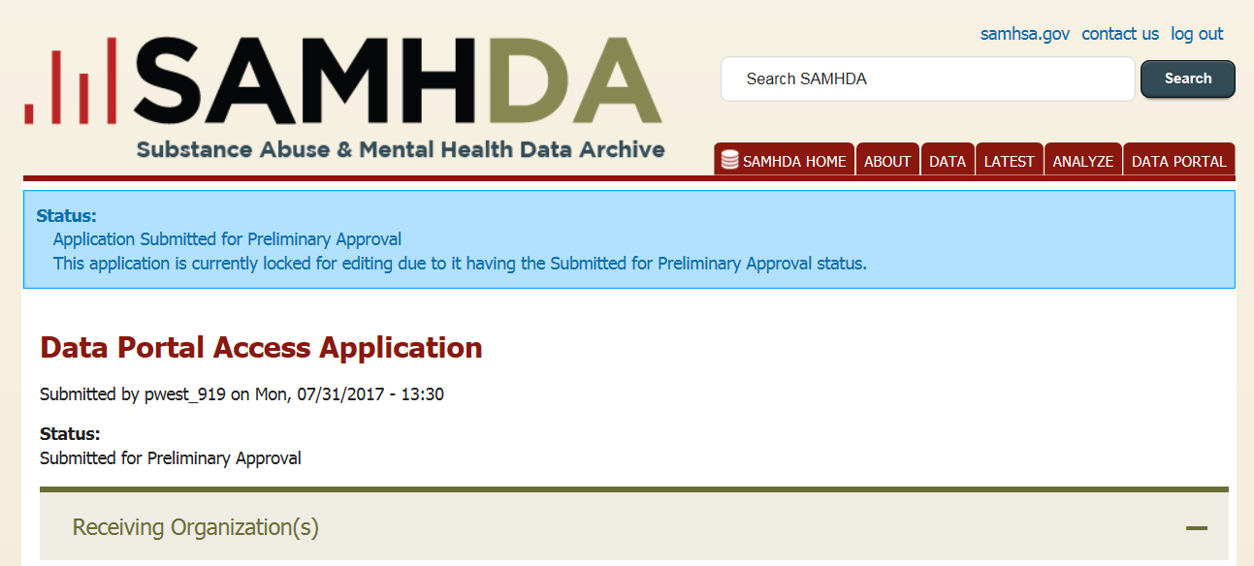
Figure 23: A successfully submitted preliminary application.

6 Notification and Final Steps
SAMHDA will notify applicants of the status of their application via email within two weeks. If preliminary approval is received, the PPO will receive instructions for finalizing the application. At this stage, additional documentation will be uploaded where indicated in the application.
Team members will receive two emails:
- An email will notify team members that an account has been created for them and will provide instructions in how to access their account and reset their passwords to work on the application.
- An email will provide a link to a quiz. To take the quiz they first need to login.
The following final documentation is required:
- Curriculum vitae for each project member (except the ROP).
- Designation of Agent and Affidavit of Nondisclosure (for nonfederal employees).
- Confidential Data Use and Nondisclosure Agreement.

The PPO will need to upload the Designation of Agent and Affidavit of Nondisclosure for every team member and the Confidential Data Use and Nondisclosure Agreement for the receiving organization before requesting final approval.

7 Troubleshooting and Support
To reach the SAMHDA Help Desk, click Online Technical Assistance at the bottom-right of any page on the SAMHDA website. The link opens a web form that will notify the Help Desk when submitted.
The Help Desk can be reached directly at 888.741.7242. Please leave a message if you are calling outside normal business hours (8 a.m. to 5 p.m. Eastern Time). At the bottom-left of the screen, you may also click Report Problem with SAMHDA site to report technical issues (see Figure 24).
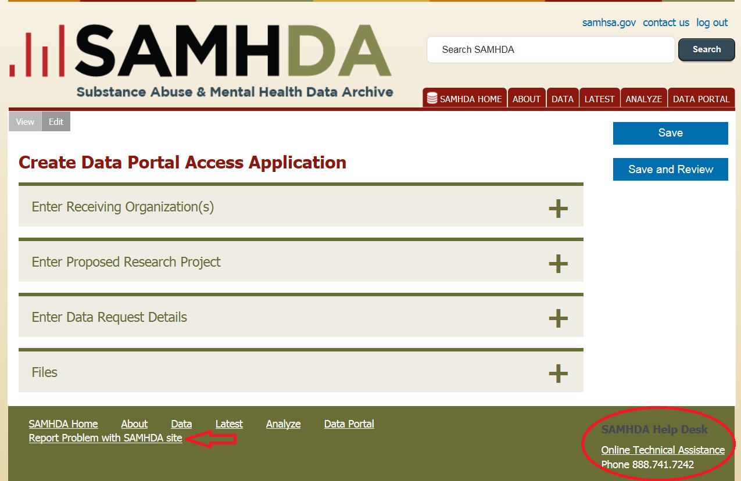
Figure 24: Links to assistance from SAMHDA’s Help Desk are in the footer on every page.

Appendix A: Acronyms
Acronym | Definition
CBHSQ | Center for Behavioral Health Statistics and Quality
DAWN | Drug Abuse Warning Network
FWA | Federalwide Assurance
IP | Internet Protocol
MB | megabytes
MPA | Multiple Project Assurance
NSDUH | National Survey on Drug Use and Health
PPO | Principal Project Officer
ROP | Receiving Organization Representative
SAMHDA | Substance Abuse and Mental Health Data Archive
SAMHSA | Substance Abuse and Mental Health Services Administration

