To import a tab-delimited data file into Excel, perform the following steps:
- Within the dataset you want to download, click the Delimited link in the Dataset Downloads section at the bottom of the page.
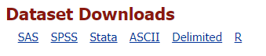
- Click Yes to agree to the SAMHDA Terms of Use.
- Select whether you want to open or save the file. Most of the files downloaded from the SAMHDA site are compressed into a tsv.zip file. The system saves the tsv.zip file in your computer’s Downloads folder, which looks similar to the following:
- Double-click on the tsv.zip file. Two folders display, one for data and one for info, similar to the following:
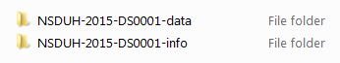
- Open the data folder and double-click the TSV or CSV file (for example: NSDUH-2015-DS0001-data-excel.tsv or N0MHSS-2015-DS0001-data-excel.csv) to open it in Excel. Because the files are quite large, this may take a minute or so to load.
- If the TSV file is not recognized by Excel, right-click it and select Open With > Excel.
- Review the imported data file. Row 1 will contain the names of the variables. Column A will be the ID variable.
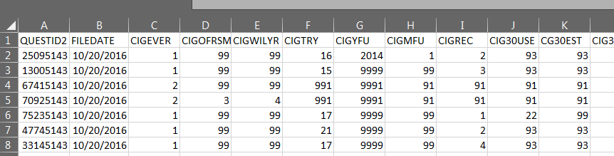
- To confirm that the import worked properly, scroll across and down to check the number of variables and cases imported. Compare these figures against those provided by SAMHDA for this file.

